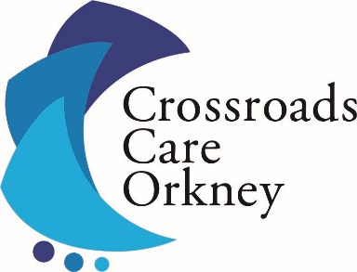

**Assistant Manager/Care Coordinator**

Applications are invited for the above post at Crossroads Care Orkney, to assist, oversee and coordinate the day to day running of all our Services: The Carers Centre, Carer Respite & the Young Carers Support Service.

We are looking for an enthusiastic person to join our team with an understanding and empathetic approach to Unpaid Carers and those for whom they care.

35 hours per week

Salary: £30,950

Closing date: **Wednesday 21st May at 12 noon**

Prospective applicants are invited to discuss the post by contacting:

Sheila Ritch on 01856 870500

or by email at [sheila.ritch@crossroadsorkney.co.uk](mailto:sheila.ritch@crossroadsorkney.co.uk)

Application form and job description available by emailing [carers@crossroadsorkney.co.uk](mailto:carers@crossroadsorkney.co.uk)

Crossroads Care Orkney, Kirkwall Travel Centre, West Castle Street, Kirkwall,

KW15 1GU.

Registered Charity No. SC022786 Company No 164342